Installing the Drupal 8 – GlobalSight Connector

Contents

Prerequisites 3

TMGMT Module 3

Installing and Configuring the TMGMT Module 3

Configure your Target Languages 4

GlobalSight Translator Module 5

Install GlobalSight Translator 5

Enable GlobalSight Translator 5

Configure the GlobalSight Translator 6

Translator Settings 6

GlobalSight Translator Plugin Settings 6

Enable Translation for Content Types 7

Demo Instance Credentials 8

Submitting content for Translation 9

Request translation 9

Add to cart 11

Translation Workflow in GlobalSight 12

Dispatching Translation Task 13

Accepting Translation Task 14

Setting up MySQL for Multilingual Drupal 19

Create a mySQL User for Drupal 20

Remove anonymous mysql accounts 20

Create a mySQL database for Drupal 20

Configure the Drupal database 20

# Prerequisites

Installation assumes an existing Drupal environment is setup, this consists of a LAMP/WAMP Server with Drupal setup.

In order to setup Drupal correctly for multilingual content the database should be in UTF-8 format. If it is not then a backup of the database should be performed and the then convert it to UTF-8

Use the ALTER DATABASE and ALTER TABLE commands.

ALTER DATABASE dbname CHARACTER SET utf8 COLLATE utf8_unicode_ci;

ALTER TABLE tblname CONVERT TO CHARACTER SET utf8 COLLATE utf8_unicode_ci;

Instructions for initial setup are included at bottom of this document.

## TMGMT Module

Drupal 8 has moved the majority of multilingual option into the core install. The GlobalSight Translator module only requires installation of the (TMGMT) Translation Management Tool module.

### Installing and Configuring the TMGMT Module

Download the TMGMT (Translation Management Suite) module from: <http://drupal.org/project/tmgmt>.

Extract to /drupal/htdocs/modules/

Activate the following module features:

* Translation Management Core
* Export / Import File
* Content Entity Source

All other dependencies will be automatically installed when these are enabled.

**NOTE**: Local Translator must not be enabled, it will result in WSOD, adequate fix not yet provided by TMGMT modules developers.

### Configure your Target Languages

You will need to configure the suite to support the languages you require. So, in Drupal, go to **Configuration** > **Regional and language** > **Languages** and add the languages you require.

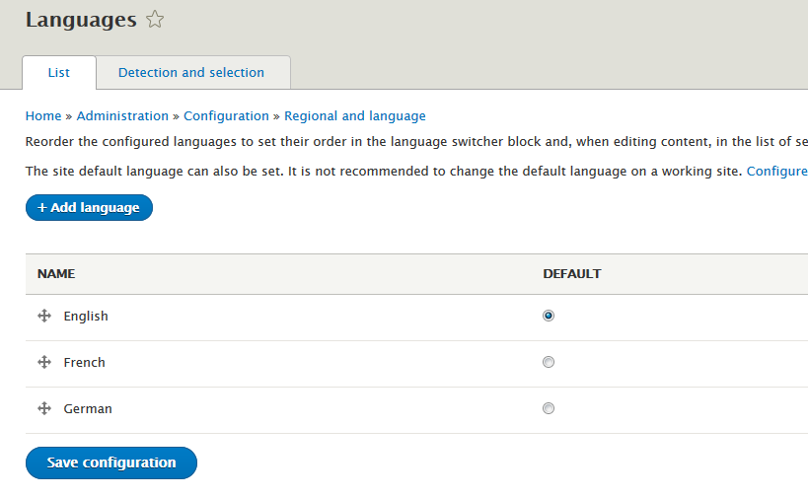

## GlobalSight Translator Module

The GlobalSight module is implemented as an additional translator for the TMGMT module. It is not yet available for download from the Drupal site, manual install is required.

**Note**: Info below on nusoap is for reference only. In its current form the GlobalSight module has been packaged with the nusoap library included, but the official release will likely separate the two again.

### Install GlobalSight Translator

Copy the module ‘tmgmt_globalsight-8.x-1.0-alpha1.zip’ to the /drupal/htdocs/modules/ directory

Extract the zip, it will create a ‘tmgmt_globalsight’ directory.

#### Reference Info Install the nusoap Library

The connector requires that the nusoap 0.9.5 library is installed: <http://sourceforge.net/projects/nusoap>. Download the library and extract it to the tmgmt_globalsight/lib folder. Rename the nusoap 0.9.5 directory, remove the version number so you end up with several php files in the ‘tmgmt_globalsight/lib/nusoap/lib’ folder.

### Enable GlobalSight Translator

In Drupal select the **Extend** menu (admin/modules) and scroll to **Translation Management** section. Select the checkbox for **GlobalSight Translator** and click **Install**.

### Configure the GlobalSight Translator

Go to **Translation** > **Providers** (admin/tmgmt/translators). You will see a list of installed translators for the TMGMT module. Drag GlobalSight translator to first in the list to set as preferred engine. Click **Edit** in the Operations section for the GlobalSight translator.

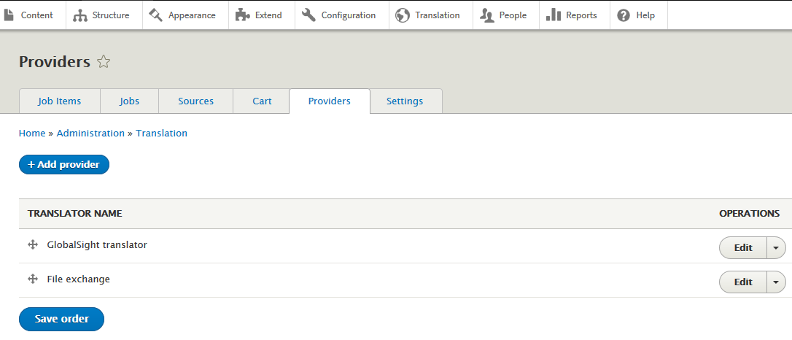

### Translator Settings

Select **Auto-accept finished translations**. We will typically handle the review process as part of the GlobalSight workflow rather than with TMGMT.

### GlobalSight Translator Plugin Settings

The plugin settings will look like this:

**Webservice Endpoint URL**: https://<gsServer>/globalsight/services/AmbassadorWebService

**Globalsight username:** User account with create job permissions

**Globalsight password:** relevant password for specified user

**File profile name:** Input the file profile name provided to you for translating content in GlobalSight.

**Remote Languages Mappings**

Drupal/TMGMT does not use language/country identifiers in the same way GlobalSight does, Drupal uses two character language codes while GlobalSight uses ‘language_County’ codes.

We need to map the TMGMT IDs to those in GlobalSight, e.g.

TMGMT: French(fr) 🡺 GlobalSight: fr_FR

TMGMT: German(de) 🡺 GlobalSight: de_DE

# Enable Translation for Content Types

In order to use Translation Management on a Content Type, you must make it language aware. Go to **Configuration** > **Regional and Language** > **Content language and translation** and select the checkbox beside the required types under **Custom language settings**.

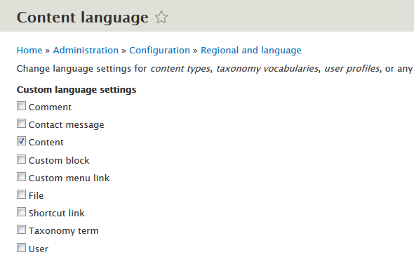

For each type selected a list appears where you can enable translation via checkboxes. You can select the top level for each Content Type to enable translation of all fields or enable individually.

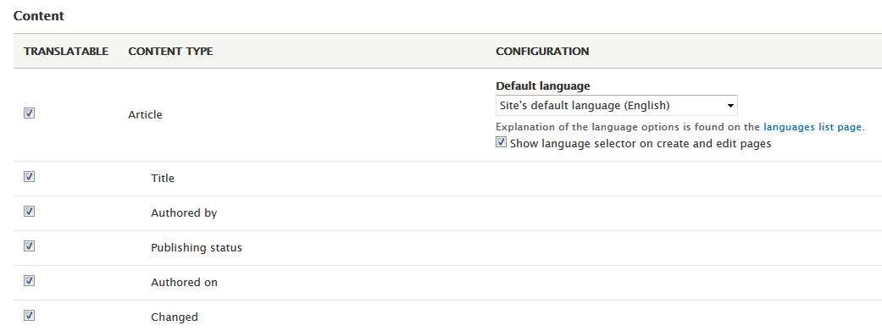

After configuring click the **Save configuration** button.

# Demo Instance Credentials

**Webservice Endpoint URL**:

<https://w14.globalsight.com/globalsight/services/AmbassadorWebService>

**Globalsight username:**

nvidia_demoadmin

**Globalsight password:**

password

**File profile name:**

Nvidia_Drupal_XML

File profile is configured to accept French (fr_FR), Italian (it_IT), German (de_DE), Spanish (es_ES) and Japanese (ja_JP).

# Submitting content for Translation

Once translation has been enabled, a new option will appear for content on the Drupal site. Click **Translate** to take you to Translations screen.

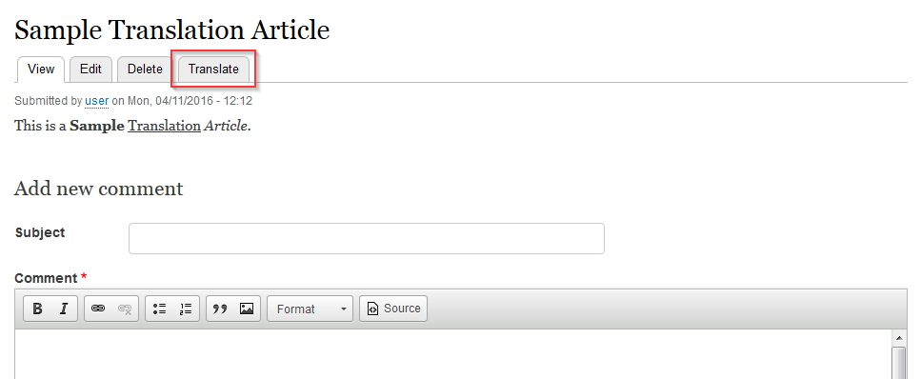

Translations screen shows an overview of the translation status of that content. To Request a translation, select the checkbox beside required languages and click **Request translation**. If you wish to submit multiple content pieces you can instead click **Add to cart** and then request the translation at a later stage.

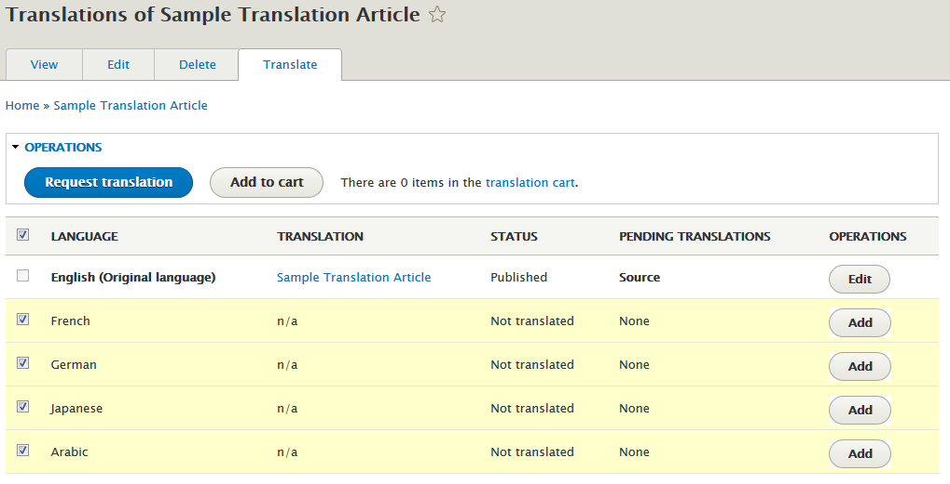

## Request translation

Clicking Request translation takes you to the Job overview screen. Here you can review the job items and the Drupal calculated word count. Note wordcounts can differ between Drupal and the translation provider plugin.

You can set a custom label for the job or leave blank. Leaving blank will submit the job with the article name and a randomised ID.

If GlobalSight translator is set as preferred translate plugin it will default it will already be selected in the Provider list.

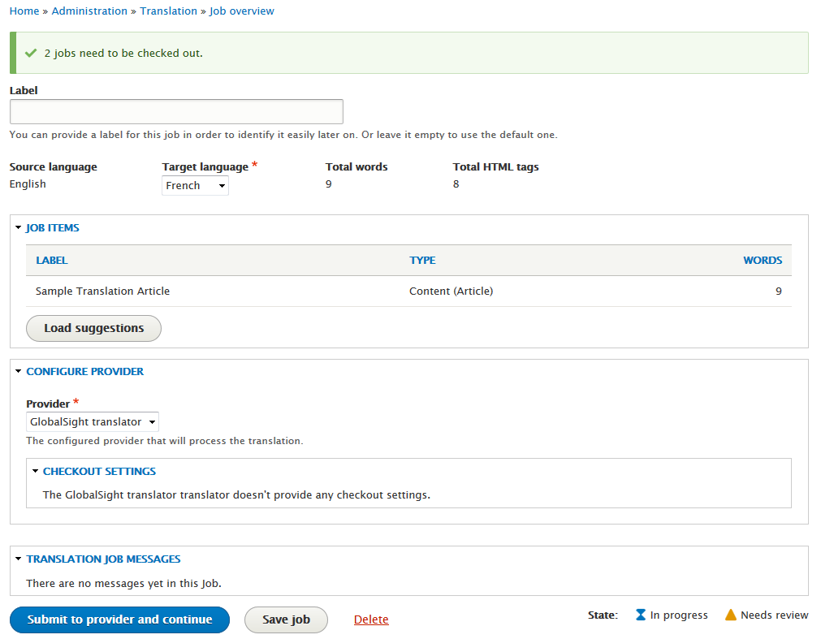

When you click **Submit to provider and continue,** the next language from your request will load up in the screen. When you reach the last language to be submitted button label changes to **Submit to provider**.

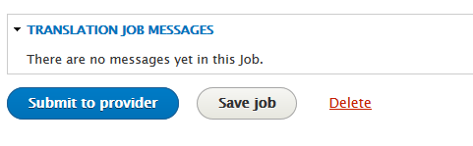

## Add to cart

If you select the Add to cart option, load the **Translation** > **Cart** screen to view pending requests. The card screen allows you to:

* Select the content items for translation
* Specify required languages
* Remove individual cart items
* Empty cart of all items

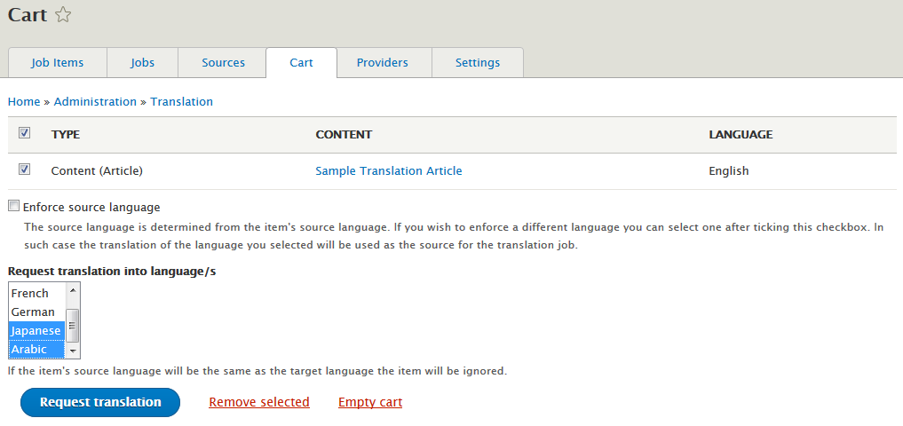

At this point you select **Request translation** where you are re-directed to the Request translation page.

# Translation Workflow in GlobalSight

Login to GlobalSight with the translator module credentials, you are then presented with the Home screen.

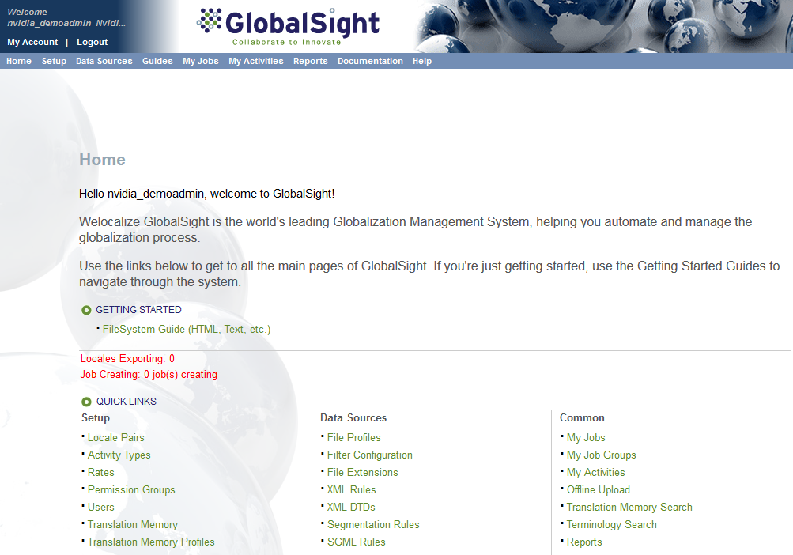

## Dispatching Translation Task

From the **My Jobs** menu select **All Jobs**. Any jobs submitted from Drupal will be present in the list that appears.

Select the job name to see job details page.

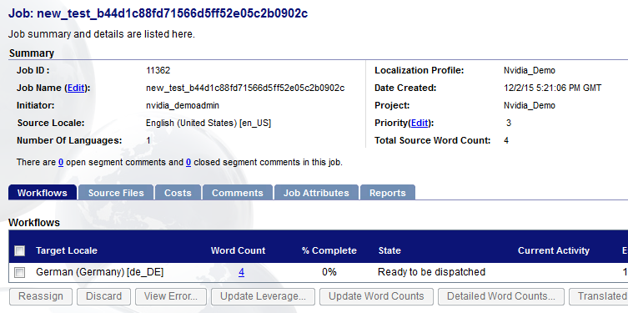

In the current setup Workflow dispatch is set to manual but this can be changed to auto dispatch.

Select the checkbox beside the target locale and click the **Dispatch** button.

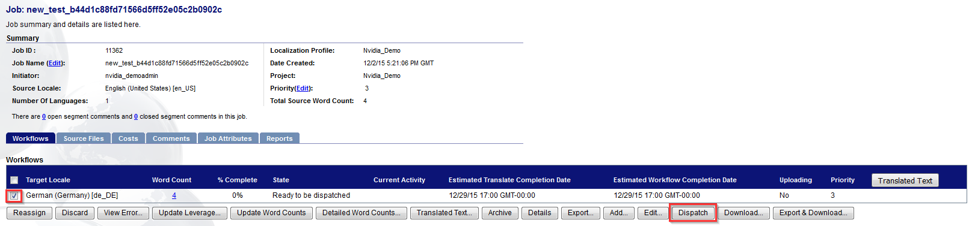

The Job is now dispatched and becomes available for translator to work on

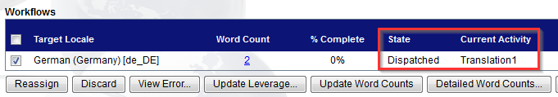

## Accepting Translation Task

Next step is to login as either the nvidia_demoanyone or nvidia_demotranslator accounts and accept the task.

Using the anyone account will give you access to all steps on the workflow and allow you to complete the job.

nvidia_demoanyone

password

Once logged in you see on the Home screen that there is an activity available

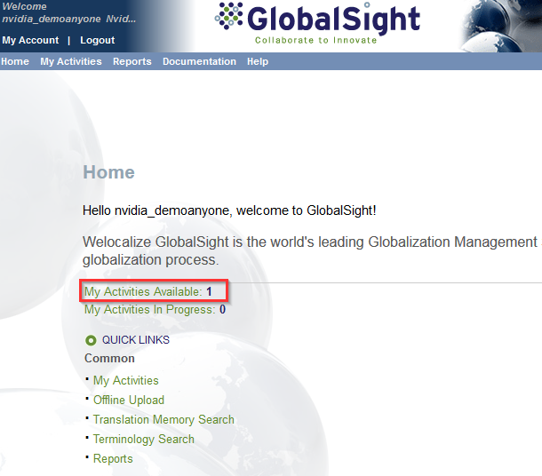

You can click that directly or navigate to it through the **My Activities** menu

Once in My Activities you’ll see the list of all that are available, you can select checkbox and Accept on this screen or click on the job name and accept from there.

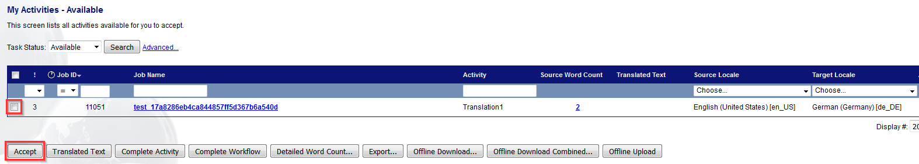

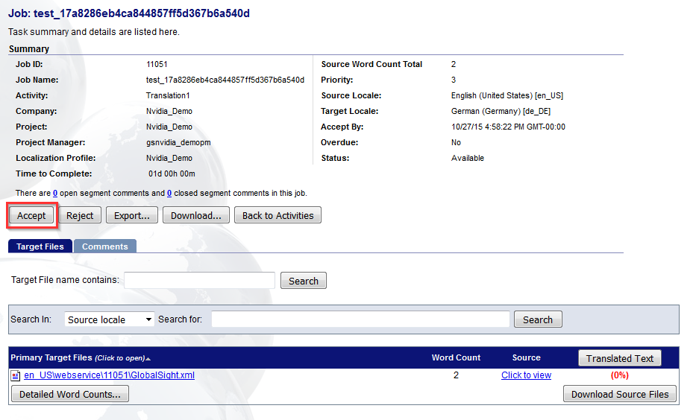

Once you have accepted the activity you can edit the translation by clicking on the files in the list under **Primary Target Files**

This will open the Main Editor which has a list of all segments that require translation.

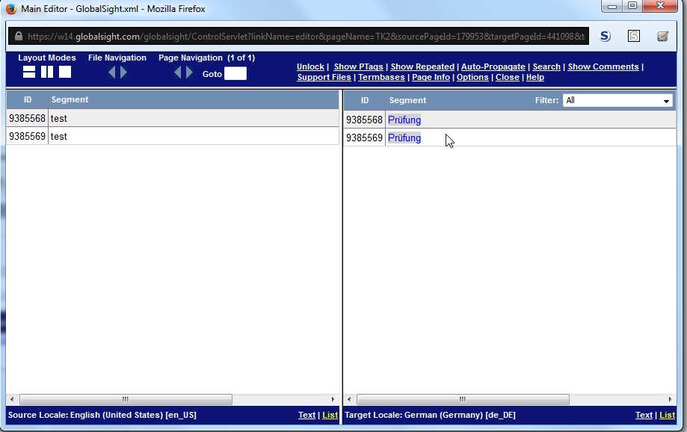

Clicking on each segment in the right side pane will launch the **Segment Editor** window. This allows you to input the target text and save the segment.

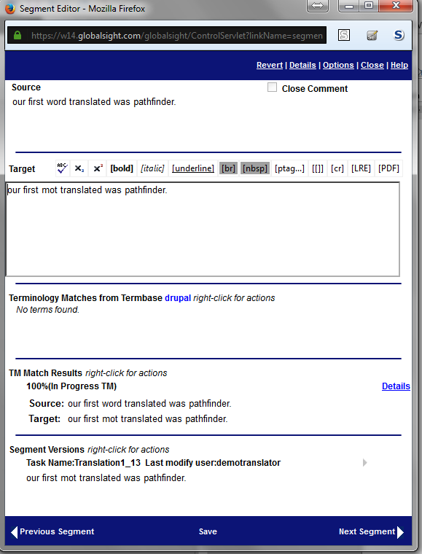

Once all translations are entered you can verify a task is fully translated by clicking the **Translated Text** button on the activity screen, it will show that overall percentage translated so the task can be completed.

**Note**: Placables (non-translatable strings, glossary terms, numbers etc.) can bump the translation percentage downward.

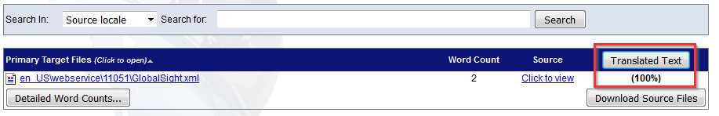

Once finished click **Task Completed** and it moves to the next step in the workflow.

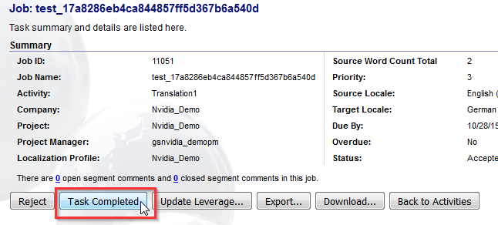

Depending on the workflow the translation can move directly from this point back to the Project Manager to finish out the job or there may be a review step (or several) in-between. For this workflow there is a review step.

If you return to the **My Activities** – **Available**, you will see the review task on the same job is no waiting to be accepted. For purposes of the test, accept and complete the task.

When the review is finished their task they have the option to send the job back to the translator at Translation2 or if happy push to the end of the workflow for Final approval. Select **Final_approval** in this instance.

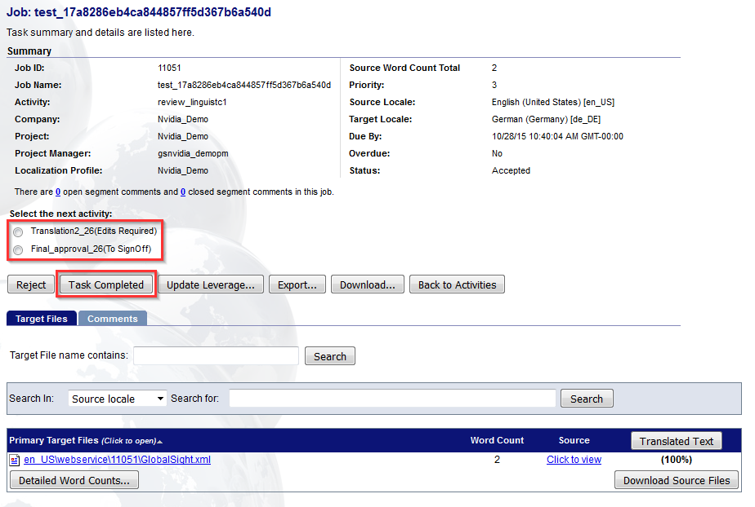

Job then moves to the final stage, where PM/anyone account can accept the task and complete the job.

Upon completion the job status will be picked up by Drupal when a cron is run.

Status of the job will change and translations will be populated into Drupal.

# Setting up MySQL for Multilingual Drupal

Before installing Drupal, you need to make a change to some of the default MySQL settings. Modify the my.ini/my.cnf file to include the following lines in the [mysqld] section:

character-set-server=utf8

collation-server=utf8_unicode_ci

Then restart MySQL.

This ensures that that new databases default to UTF8 and that the collation is Unicode-based rather than the out-of-box default of Swedish.

### Create a mySQL User for Drupal

1. Select phpMyAdmin from the WAMP tray icon.
2. Select the Users tab and click Add User.
3. In the Login Information section:  
   Enter a user name, e.g. drupalroot  
   Select “local” from the Host dropdown list  
   Enter a suitable password and then retype it in the second location for confirmation.
4. In the Database for user section:  
   Select Create database with same name and grant all privileges
5. Click Go.

### Remove anonymous mysql accounts

mysql> delete from user where user='';

Query OK, 2 rows affected (0.01 sec)

mysql> select user,host,password from user where user='';

Empty set (0.00 sec)

mysql> flush privileges;

**Note**: If running on CentOS, the mysql install wizard will provide the option to remove anonymous users during setup

### Create a mySQL database for Drupal

1. Select phpMyAdmin from the WAMP tray icon.
2. Select the Databases tab.
3. In the Create Database section:  
   Enter the Drupal database name, e.g. drupal_db  
   Select utf8_unicode_ci from the Collation dropdown list
4. Click Go.

### Configure the Drupal database

1. Navigate to <drupalfolder> and run install.php.
2. Select the defaults for Profile and Language. If your installation is ok so far, the Verify requirements step should be auto-ticked.
3. In the Setup database section, enter your database data: e.g.  
   Type: mySQL  
   Database Name: drupal_db  
   User name: drupalroot **\***Password: password
4. On the Configure Site page, enter your site information and site maintenance account data.  
   In the Site Information section: e.g.  
   Site name: drupaldemo  
   Site email: [your.name@domain.com](mailto:your.name@domain.com)  
   In the Site Maintenance Account section:  
   User name: drupalroot  
   Password: password  
   Email: [your.name@domain.com](mailto:your.name@domain.com)